A Victorian Christmas with John Doan - Technical Requirements:

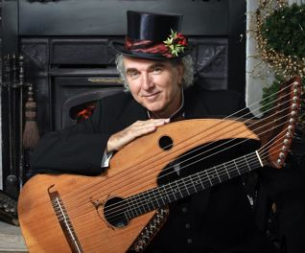

Artist provides:

Antique instruments, mock fireplace, parlor props, computer for powerpoint of archival images

Sponsor provides:

Two six foot tables with coverings
One small table (average height) for mechanical instruments
Video projector to connect to artist provided mac computer powerpoint and projection screen *
General lighting and/or spotlight with stand (amber, pink, and blue gels) *
PA system *
Three microphones 1.) on low boom for instruments 2.) wireless lapel for speaking 3.) microphone for phonograph
CD player for music prior to show and intermission (artist provides CD)
One six-foot table for CD sales in lobby

*Artist can provide for NW concerts

Stage requirements:

Artist can adapt staging for almost any configuration (preferably 15' wide, 10' deep)
Artist prefers to set up in concert space 4 hours prior to concert with exclusive use of space until tear down
Sound and lighting checks can be made one to two hours prior to show time
Artist requests assistance in load in, tear down and load out (one or two assistants is fine)

If there are any questions contact John Doan at:

6638 River Springs Dr. S.,
Salem, OR 97306-9711
503-364-4787 Home
503-370-6174 Office
503-559-8081 Cell phone
<jdoan@johndoan.com> email
or visit website at <www.johndoan.com>

