Beyond Six Strings and a Celtic Pilgrimage with John Doan
Technical Requirements

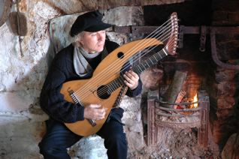

Beyond Six Strings:

A chair without arms, a microphone for speaking, and a single line out from my portable mixer.

Celtic Pilgrimage:

Same as above but if interested in the multimedia presentation:

DVD/video projector * (Artist provides DVD of Celtic image sequence with dissolves)
Eight ft. or larger projection screen *
Focused spotlight with stand (amber, pink, and blue gels) *
PA system (with at least 4 channels) 3 channels in for instrument *
One microphone for speaking (preferably lapel wireless).
Chair for artist (can be piano stool or other armless chair)
One audio direct box from quarter inch to XLR output (artist can provide)
Attendant to monitor DVD projector (can be controlled by remote)
CD player for music prior to show and intermission (artist provides CD)
One six-foot table for lobby for CD and tape sales.
*Artist can provide for NW concerts

Stage requirements:

Artist can adapt staging for almost any configuration. Artist prefers to set up in concert space 4 hours prior to concert with exclusive use of space until tear down. Sound/lighting checks one to two hours prior to show time.

If there are any questions contact John Doan at:
6638 River Springs Dr. S.,
Salem, OR 97306-9711
503-364-4787
mailto:harpguitar@gmail.com or visit website at http://www.johndoan.com

