A Celtic Pilgrimage with John Doan

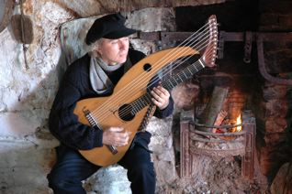

Technical Requirements:

Sponsor provides:

DVD/video projector * (Artist provides DVD of Celtic image sequence with dissolves)
Eight ft. or larger projection screen *
Focused spotlight with stand (amber, pink, and blue gels) *
PA system (with at least 4 channels) 3 channels in for instrument *
One Microphone for speaking (preferably lapel wireless).
Chair for artist (can be piano stool or other armless chair)
Three audio direct boxes from quarter inch to XLR output (artist can provide)
Attendant to monitor DVD projector (can be controlled by remote)
CD player for music prior to show and intermission (artist provides CD)
One six-foot table for lobby for CD and tape sales.

*Artist can provide for NW concerts

Stage requirements:

Artist can adapt staging for almost any configuration (needs only single chair and projection screen)
Artist prefers to set up in concert space 4 hours prior to concert with exclusive use of space until tear down
Sound and lighting checks can be made one to two hours prior to show time.

If there are any questions contact John Doan at:
6638 River Springs Dr. S.,
Salem, OR 97306-9711
503-364-4787 Home
503-370-6174 Office
503-559-8081 Cell phone
<jdoan@johndoan.com> email
or visit website at <www.johndoan.com>

